**Software Design & Architecture**

**Project Deliverable**

Design Phase - I

Submitted To: Dr. Amir Malik

**Group Members:**

* Muhammad Hassnain (22L-7931)
* Ahmed Moeez Azeem (22L-7966)
* Hammad Talat (22L-7858)
* Abdul Ahad Tariq (22L-7866)
* Tayyab Kamran (22I-2505)
* Uzair Ahmed (22I -1503)

**Contents:**

* Use Case Diagram
* Class Diagram
* A blue circle with white text and a green and yellow letter

  Description automatically generatedSequence Diagram

**Use Case Diagram**

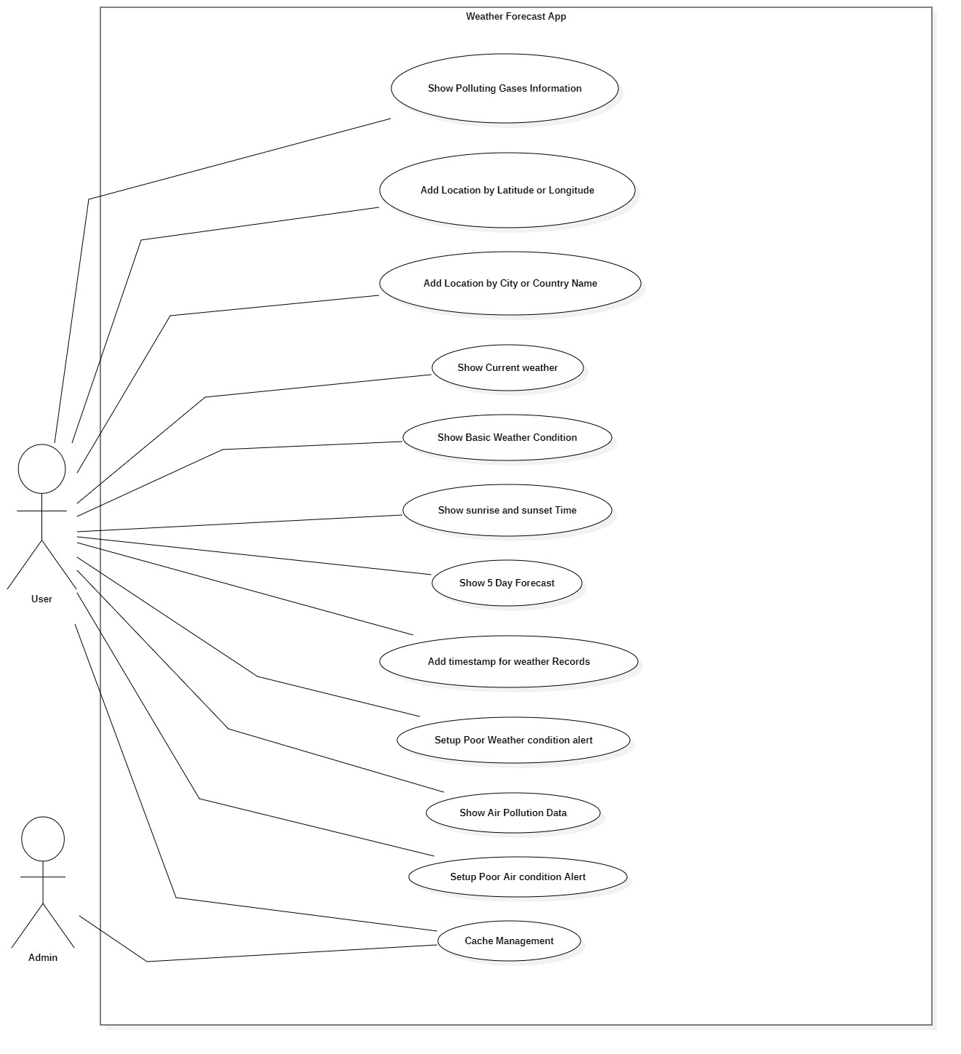

**Class Diagram**

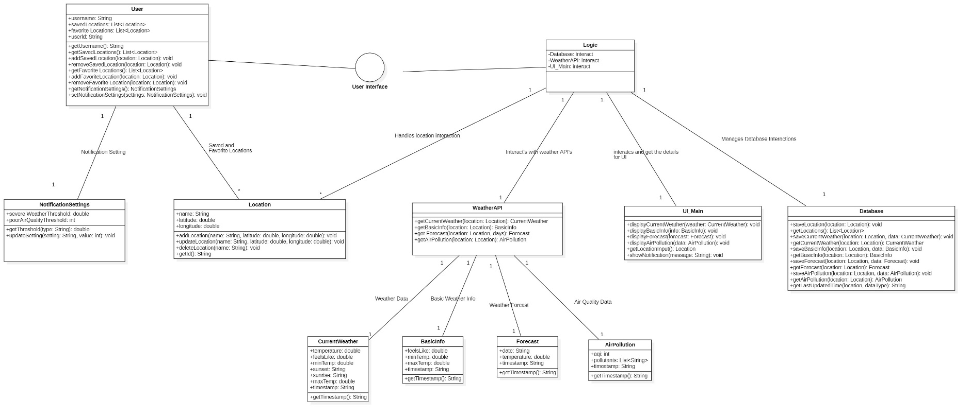

**Sequence Diagrams**

**Use Case 1** (Add Location to check Weather with Longitude and Latitude)

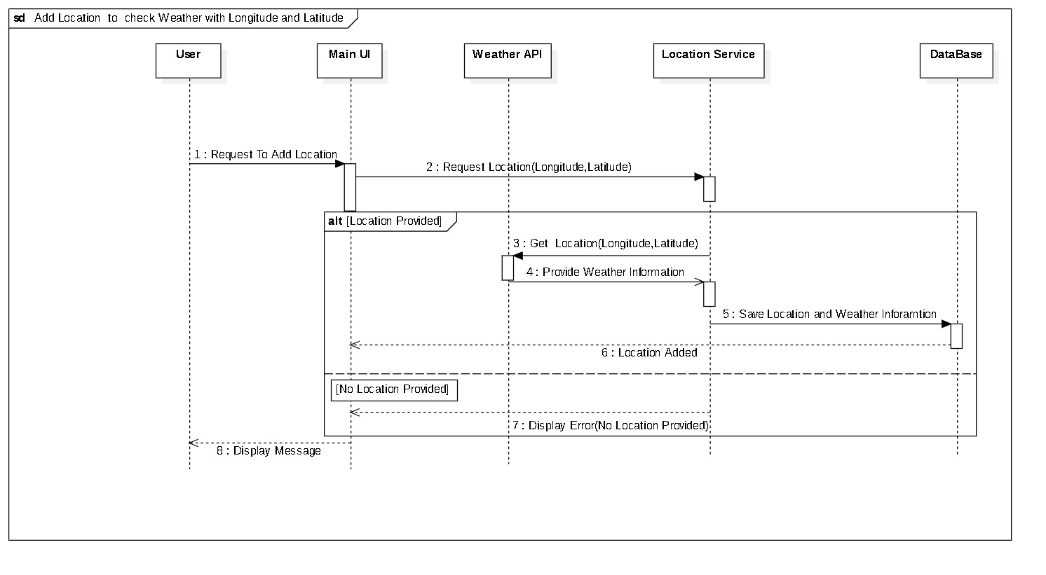

**Use Case 2** (Add Location to check Weather with Country / City Name)

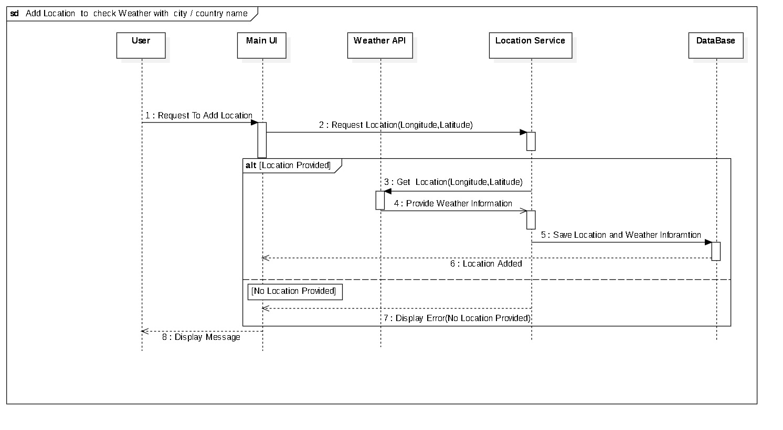

**Use Case 3** (Show current weather conditions)

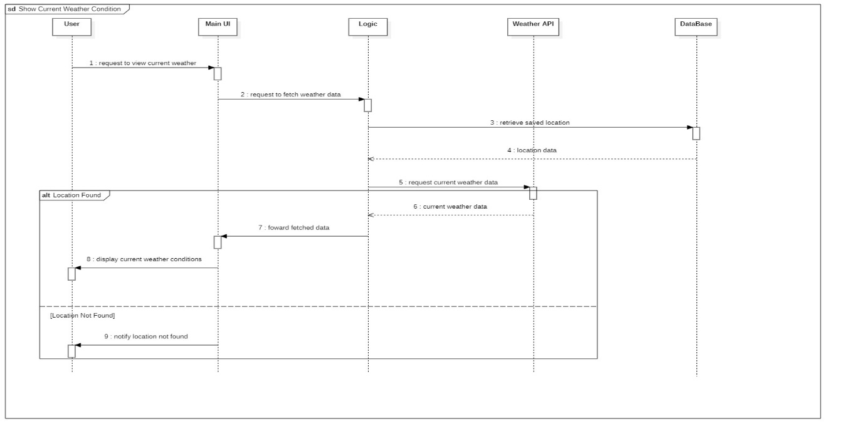

**Use Case 4 (**Show basic information like “Feels like, minimum and maximum temperature”)

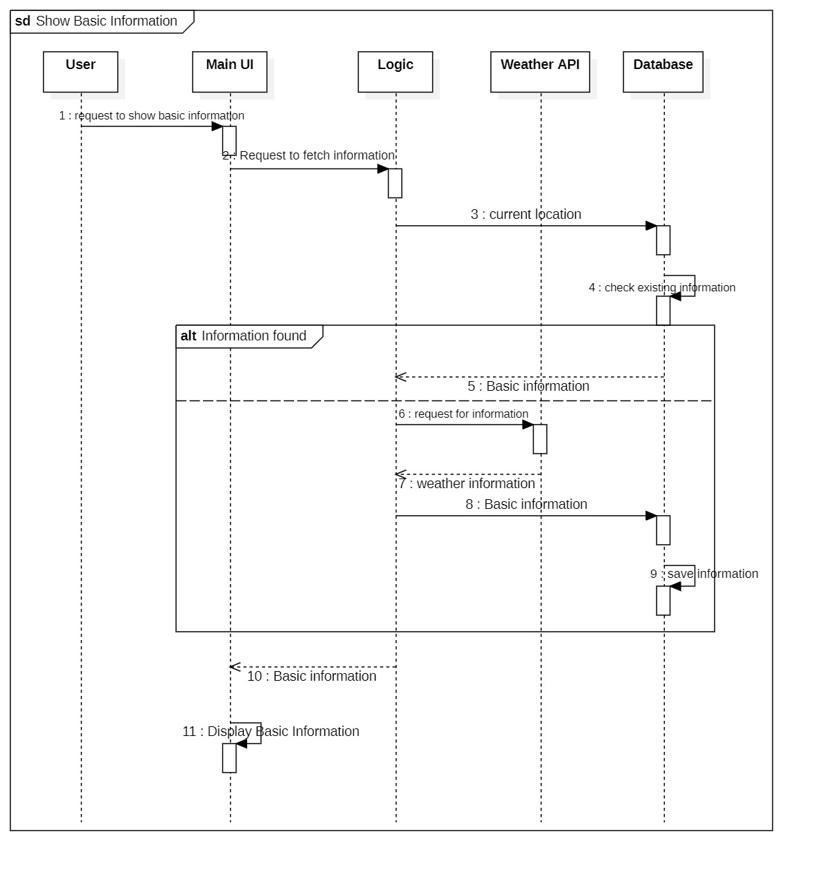

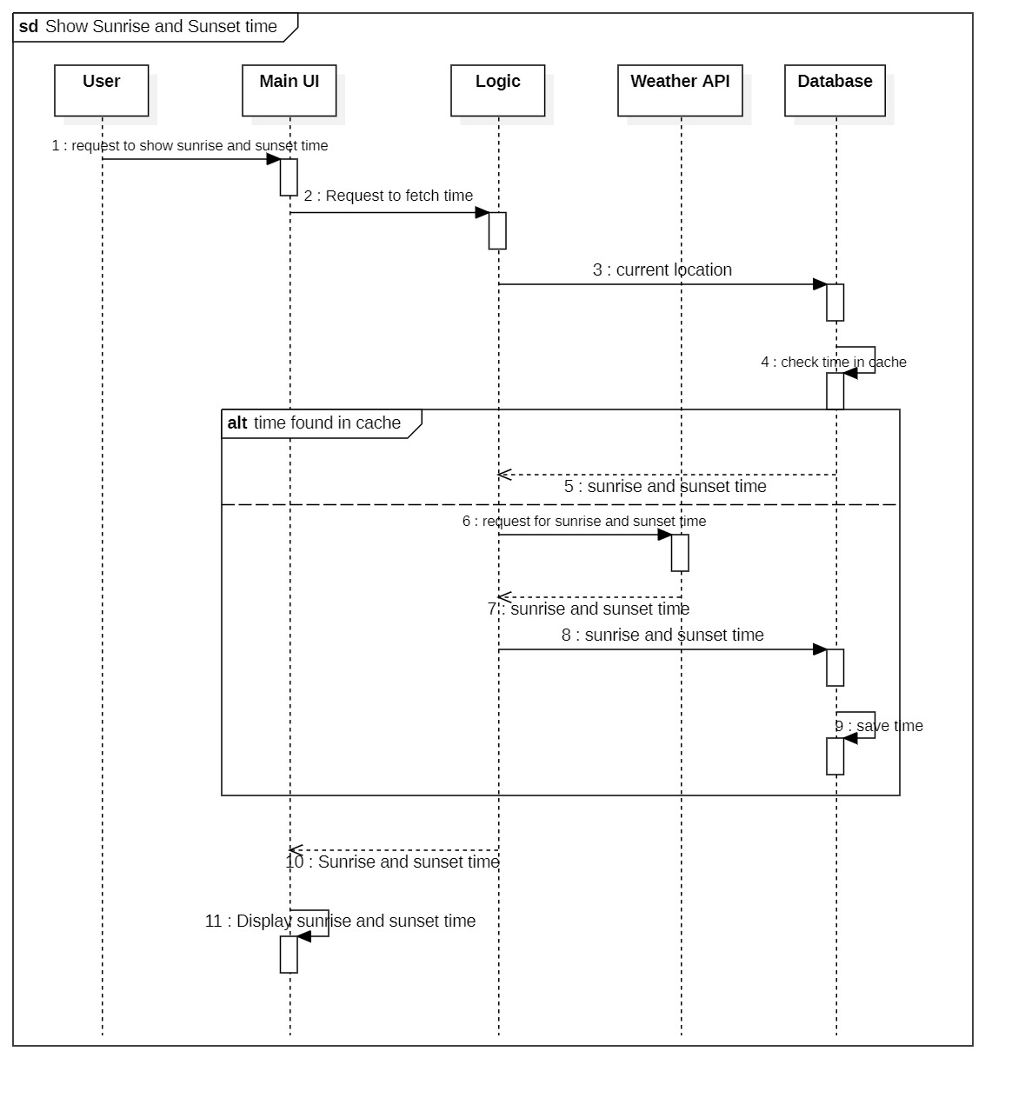**Use Case 5** (Show sunrise and sunset time)

**Use Case 6** (Show weather forecast for 5 days)

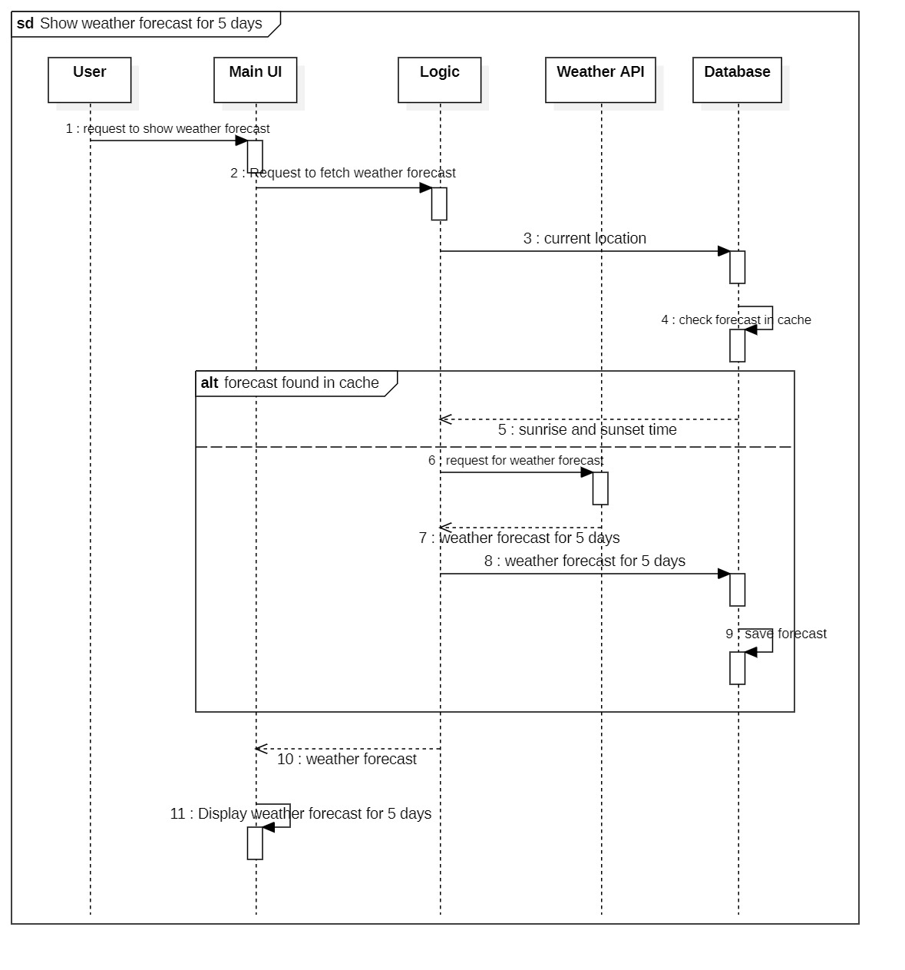

**Use Case 7** (Add timestamp for weather records)

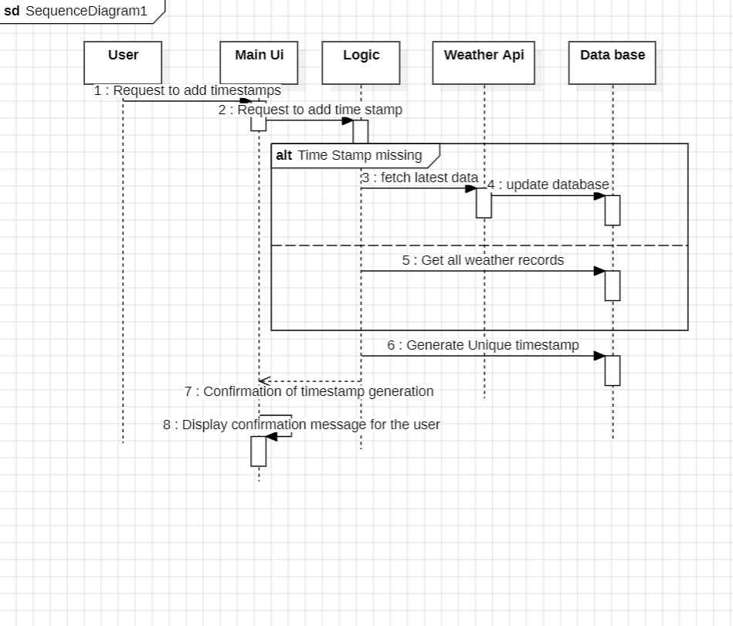

**Use Case 8** (Implement Cache Management)

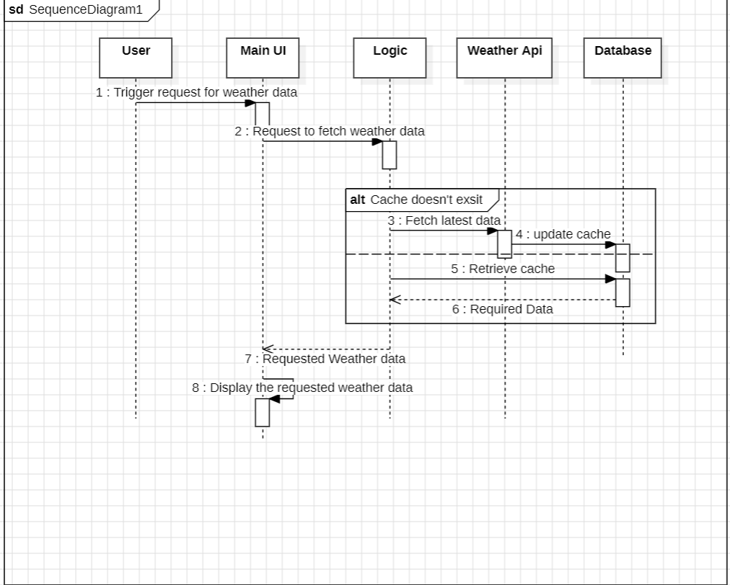

**Use Case 9** (Generate Notification for poor weather conditions)

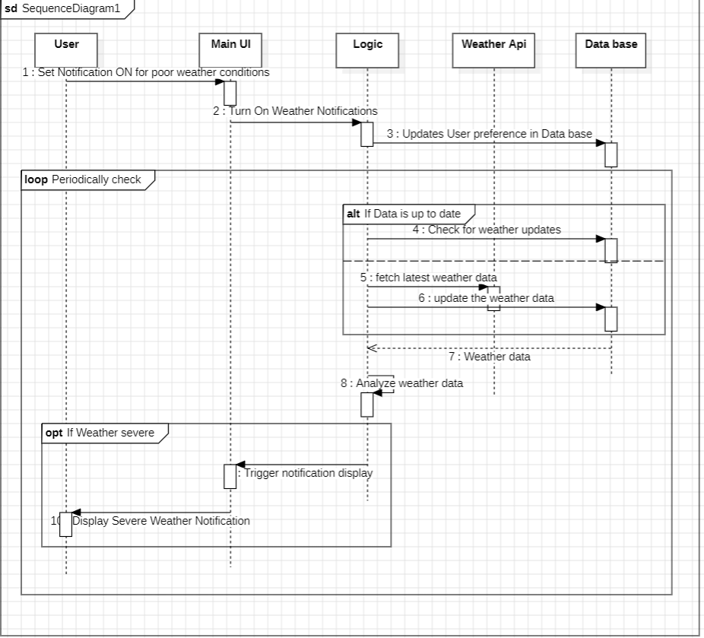

**Use case 10** (Show Air Pollution data)

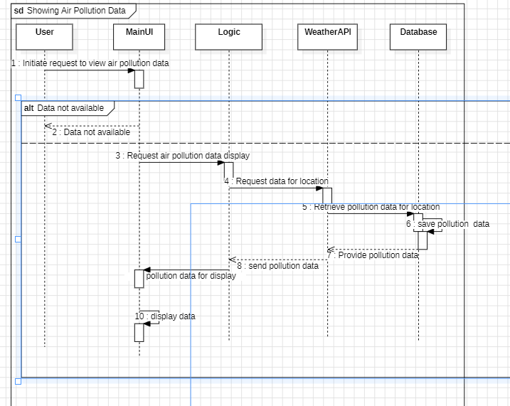

**Use Case 11** (Generate Notification for poor air quality)

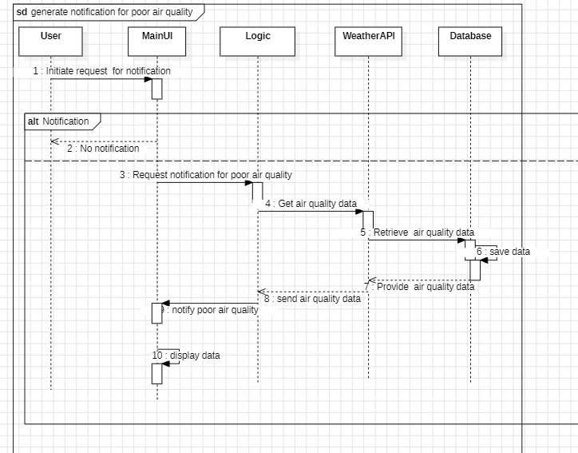

**Use Case 12** (Show data about polluting gasses)

